Name_______________________

Geogebra Lesson: Construction of parallelograms and its properties

- Construct a line segment using the Segment tool

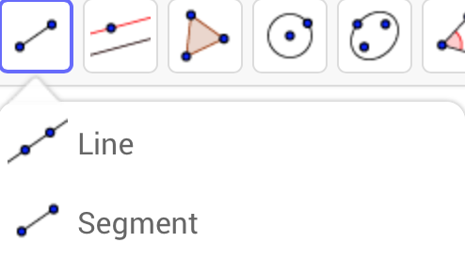

- Construct another point (not on the line segment) using the New Point tool

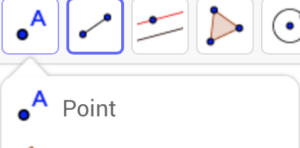

- Connect point A and C using the Segment tool

- Construct a parallel line by selecting the Parallel Line tool and click on the point C and the line segment AB.
- Construct another parallel line by selecting the Parallel Line tool and click on the point B and the line segment AC.

- Construct a point on the intersection of the two newly constructed parallel lines using the Intersect Two Objects tool
- Make sure this point is labeled as “D”
- Select the Polygon tool and select the four vertices of the parallelogram
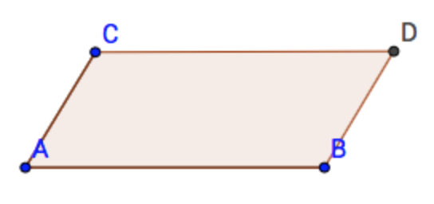

Now let’s look at the six properties of a parallelogram:

- Opposite sides are congruent (AB = DC).
- Opposite angels are congruent (C=B)
- Consecutive angles are supplementary (A + C = 180°).
- If one angle is right, then all angles are right.
- The diagonals of a parallelogram bisect each other.
- Each diagonal of a parallelogram separates it into two congruent triangles.

- Use the Pen tool to show that opposite sides are congruent
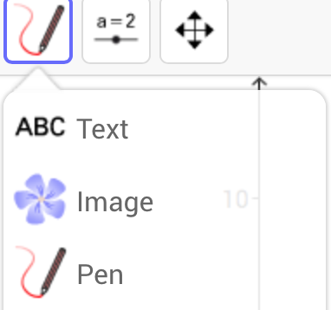

- Find the angles by using the Angle tool – show congruent angles

- Show that consecutive angles are supplementary (add up to 180)

- Move the points around to see different measurements

What happens if one angle is 90 degrees, or right?

- Draw the diagonals… where do they intersect?

