Name: __________________________________________ Date: _________________________

How Many M&M’s Can Fit?

- Goal: Students will understand how to find the volume of given objects using the formula provided.
- Objectives:
  - Given the materials, students will find the volume of the given object, which in this case is a cylinder.
  - Using the volume, students will figure out how many M&M’s fill up the object.
  - Using this information, students will understand that the volume and the number of M&M’s per object go hand in hand.
- Materials:

Cylinder objects  - Small glass flower vase  - Empty can of soup  - Garbage can (clean obviously ) | - Formulas  - M&M’s  - Graphing paper  - Ruler  - Calculator
A little review:
Definition of volume: the amount of space that a substance or object occupies, or that is enclosed within a container
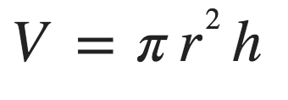
The formula for the volume of a cylinder is:
Where: r= the radius and h= height

Questions:

1) Find the volume below:

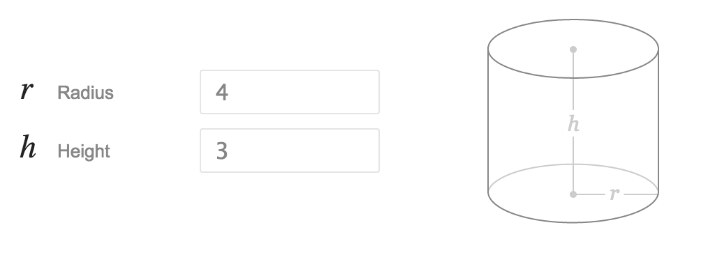
Steps:
- FIND THE DIMENSIONS OF YOUR CYLINDER
- PLUG IN DIMENSIONS INTO THE VOLUME OF A CYLINDER FORMULA
- FIND THE VOLUME AND LABEL APPROPRIATELY
- FILL THE CYLINDER WITH M&M’S
- COUNT THE M&M’S AND GRAPH!
- THINK ABOUT THE RELATIONSHIP BETWEEN THE VOLUME AND NUMBER OF M&MS

